LAB 2: Dinesh Vaithyalingam Gangatharan

Harsha Nandeeshappa Krishnarajanagar

**Preparation Exercises**

1.

%% Signal definitions

n = -10:20;

h = [1 1 1 1 ];

x1 = sin((12/100*pi).*n);

u1=(n>=0);

u2=(n>=6);

x2 = u1 -u2;

x3 = ((9/10).^n).*u1;

delta1 = (n==1);

delta2 = (n==2);

delta3 = (n==3);

x4 = ((5/10).*delta1)+ delta2+((5/10).*delta3);

x5 = ((9/10).^n).*(cos(((2/10)*pi).*n));

%x6 = sin(((2/10)*pi).*n)./(((2/10)*pi).*n);

x6 = sinc(((2/10)*pi).*n);

2. Convolution Example

x(n) = δ(n) + δ(n − 1) + δ(n − 2) 🡪 [ 0 1 2]

h(n) = δ(n) − δ(n − 1) 🡪 [0 1]

|  |  |  |  |  |  |  |  |  |
| --- | --- | --- | --- | --- | --- | --- | --- | --- |
|  |  |  |  |  |  |  |  | y(n) |
| h(n) |  | 0 | 1 |  |  |  |  |  |
| x(n) | 0 | 1 | 2 |  |  |  |  |  |
|  |  |  | 2 |  |  |  |  | 2 |
|  |  |  |  |  |  |  |  |  |
| h(n) |  | 0 | 1 |  |  |  |  |  |
| x(n) |  | 0 | 1 | 2 |  |  |  |  |
|  |  |  | 1 |  |  |  |  | 1 |
|  |  |  |  |  |  |  |  |  |
| h(n) |  | 0 | 1 |  |  |  |  |  |
| x(n) |  |  | 0 | 1 | 2 |  |  |  |
|  |  |  | 0 |  |  |  |  | 0 |

3. Second-order System

When a(1) and a(2) are zero the system is stable.

**Experiments**

6.1 Discrete Time Signals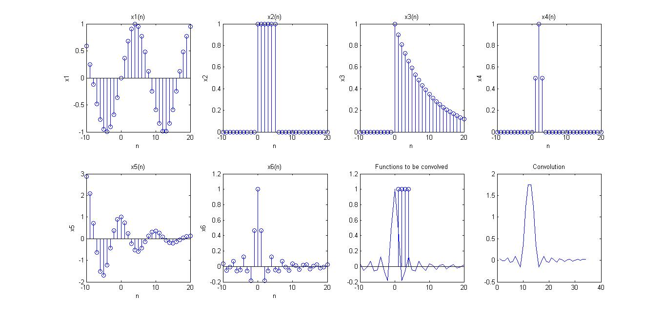

%% Plots

figure

subplot(2,4,1);

stem(n,x1);

xlabel('n');

ylabel('x1');

title('x1(n)');

subplot(2,4,2);

stem(n,x2);

title('x2(n)');

xlabel('n');

ylabel('x2');

subplot(2,4,3);

stem(n,x3);

title('x3(n)');

xlabel('n');

ylabel('x3');

subplot(2,4,4);

stem(n,x4);

title('x4(n)');

xlabel('n');

ylabel('x4');

subplot(2,4,5);

stem(n,x5);

title('x5(n)');

xlabel('n');

ylabel('x5');

subplot(2,4,6);

stem(n,x6);

title('x6(n)');

xlabel('n');

ylabel('x6');

%% Convolution

y = convmat(x6,h);

subplot(2,4,7);

plot(n,x6);

hold on;

stem(h);

title('Functions to be convolved');

subplot(2,4,8);

plot(y);

title('Convolution');

Convolution

function [ y ] = convmat( x,h )

%CONVMAT Summary of this function goes here

% Detailed explanation goes here

%x,h,y are column vectors

lenx=length(x);

lenh=length(h);

N=lenx+lenh-1;

H=[];

for (count=1:lenx)

tmp=[zeros(count-1,1);h;zeros(N-count-lenh+1,1)];

H=[H tmp];

end

y=H*x;

end

Averaging Filter

clear all;

clc;

u = ones(1,5);

h = u.*(2/10);

x1 = ones(1,9);

n = 0:35;

x2 = sin(((2/10)*pi).*n);

x3 = sin(((4/10)*pi).*n);

y1 = convmat(x1,h);

y2 = convmat(x2,h);

y3 = convmat(x3,h);

figure (1);

subplot(3,1,1);

stem(y1);

subplot(3,1,2);

stem(y2);

subplot(3,1,3);

stem(y3);

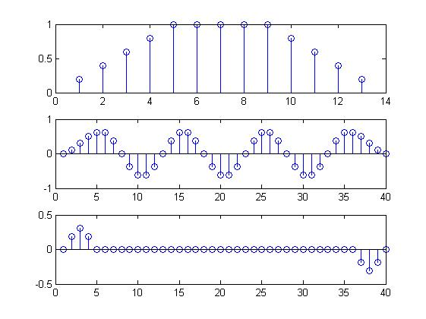

**6.2 Musical Tone Synthesis**

**Code –**

clear all

%Musical Tone Synthesis 6.2 - 1

f1 = 392; %in Hz

fs = 8192; %in Hz

t1 = 1/f1;

T = 1/fs;

starttime = 0;

endtime = 1 - T;

t = starttime:T:endtime;

s1s = sin(2 * pi * f1 * t);

% stsf = fft(s1s);

% figure(1)

% subplot(2,1,1) , stem(s1s);

% % stem(s1s);

% subplot(2,1,2) , plot(1:numel(stsf),stsf);

soundsc(s1s, fs);

disp('Press any key to continue..');

pause

% Harmonics - 2

snew = s1s;

for k = 2:8

fk = f1 * k;

pk(k) = 0.25.^(k-1);

sh = pk(k) * (sin(2 * pi * fk * t)); %harmonic

snew = snew + sh; %adding harmonic signal

end

stsf = fft(snew);

% figure(2)

% subplot(2,1,1) , stem(snew);

% subplot(2,1,2) , plot(1:numel(stsf),stsf);

soundsc(snew, fs);

disp('Press any key to continue..');

pause

%envelope - 3

A = envelope(numel(snew), 0.25, [240 7200]);

esnew = A .* snew;

ESNEW = fft(esnew);

figure(3)

subplot(2,1,1),

plot(esnew);

xlabel('t'); ylabel('x(t)');

title('Envelope of Harmonics and its FFT')

subplot(2,1,2), plot(1:numel(ESNEW),ESNEW);

xlabel('f'); ylabel('x(f)');

% piano - 4

piano = load('pianoG3.mat');

fftpiano = fft(piano.g);

soundsc(piano.g, piano.fs);

figure(4)

subplot(2,1,1),

plot(piano.g);

xlabel('t'); ylabel('x(t)');

title('Envelope of real piano data and its FFT');

subplot(2,1,2),

plot(1:numel(fftpiano),fftpiano);

xlabel('f'); ylabel('x(f)');

6.4 Bandpass Filtering

clear all;

clc;

%Sample with hidden pulses loaded

load('..\Lab_2\files_lab2\b3pulses.mat');

%Sampling frenquency (in Hz)

fs = 80000;

%Stopband and Passband Frequency ranges (in Hz)

fp1 = 5000; fs1 = 8000;

fp2 = 10500; fs2 = 15500;

fp3 = 18000; fs3 = 20000;

f01 = (fp1+fs1)/2; f02 = (fp2+fs2)/2; f03 = (fp3+fs3)/2;

%Digital frequency bands

w01 = f01/fs*2*pi;

w02 = f02/fs*2*pi;

w03 = f03/fs*2*pi;

%Range (Digital domain)

delW = [(fs1-fp1)/fs*2*pi; (fs2-fp2)/fs*2*pi; (fs3-fp3)/fs*2*pi;];

r=[];

for i=1:3

tmp=roots([4 -(8+delW(i)^2) 4]);

r=[r tmp(2)];

end

b=[1 0 -1];

a1=[1 -2*r(1)*cos(w01) r(1)^2];

a2=[1 -2*r(2)*cos(w02) r(2)^2];

a3=[1 -2*r(3)*cos(w03) r(3)^2];

figure(1);

plot(x);

title('Noisy Signal');

xlabel('Time');

ylabel('Amplitude');

figure(2);

subplot(3,1,1);

[H1,w1]=freqz(b,a1);

plot(w1/2/pi*fs/1000,abs(H1).^2);

title('Filter One');

xlabel('Frequency(kHz)');ylabel('|H(e^{ j\omega})|^2');

subplot(3,1,2);

[H2,w2]=freqz(b,a2);

plot(w2/2/pi*fs/1000,abs(H2).^2);

title('Filter Two');

xlabel('Frequency(kHz)');ylabel('|H(e^{ j\omega})|^2');

subplot(3,1,3);

[H3,w3]=freqz(b,a3);

plot(w3/2/pi*fs/1000,abs(H3).^2);

title('Filter Three');

xlabel('Frequency(kHz)');ylabel('|H(e^{ j\omega})|^2');

y1=filter(b,a1,x);

y2=filter(b,a2,x);

y3=filter(b,a3,x);

figure(3);

subplot(3,1,1);

plot(y1);

title('Output of the Filter One');

xlabel('Time');ylabel('Amplitude');

subplot(3,1,2);

plot(y2);

title('Output of the Filter Two');

xlabel('Time');ylabel('Amplitude');

subplot(3,1,3);

plot(y3);

title('Output of the Filter Three');

xlabel('Time');ylabel('Amplitude');

